DBMS- Gate Smashers

Database System has 2 thins- Database and DBMS

Data which is in form of any structure – Structured Database

DBMS (Database Management System) We perform operations on the Data. System used to perform these operations is known as DBMS.

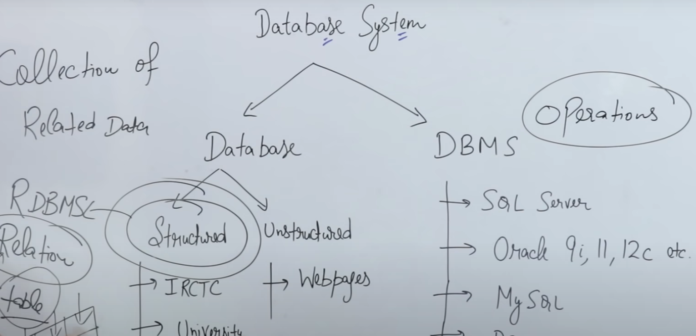

FILE SYTEM vs DBMS:

File System was used proior to DBMS. IN FS, data was managed in the form of files. (Making files in specific folder and using those files to store data)

SCHEMAS: logical representation of a database & is a collection of tables (1 or more )

Ex in RDBMS, we represent data in the form of Tables or in ER model; we represent data in form of Entity or Relationship.

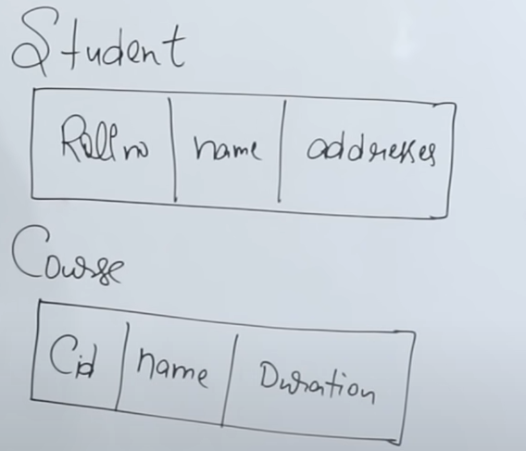

When data is stored in Harddisk or Server, it is not stored in form of Roll no/Name/address but when user access data using DBMS, we get it in form of Tables

Schema can be one table or it can have multiple tables which are related.

THREE SCHEMA ARCHITECTURE:

Key: Key is an attribute from a table and it is used to uniquely identify a record/ tuple in table.

**Candidate Key**: **CANDIDATE KEY** is a **set** of attributes that uniquely identify tuples in a table. **Candidate Key** is a super **key** with no repeated attributes.

Primary **key** should be selected from the set of **candidate keys**. Rest of the keys are alternate keys. Every table must have at least a single **candidate key**.

Phone number can be Candidate key but not a PK (ex: siblings may give a same no in the DB)

The table containing PK is called REFERENCED/BASE table and FK table is called REFERENCING Table.

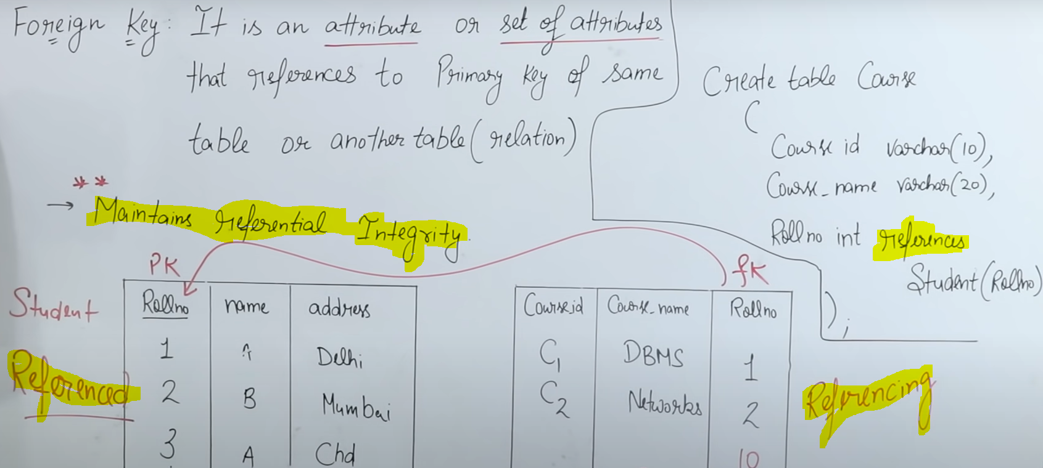

FK maintains referential Integrity for INSERTION, DELETION AND UPDATE.

Insertion into base table – no Problem

Deletion into base table – FK may/may not be associate to a record in another table. So it may or may not cause a violation.

Solution: **ON DELETE CASCADE** -- > Record deleted in a table, the tables having FK will also delete the records automatically.

ON DELETE SET NULL -- > The FK column in other tables associated with that record will be set to NULL. If a FK of a table is the PK also, then this will be an issue since PK cannot be null.

ON DELETE NO ACTION -- > Default one. This will give an error if a record of student table is deleted since the record has a FK in another table.

Same three are for UPDATE one.

Insertion in to referencing table -- > May cause violation if the a student is not present and the roll no in Course table is set to some value.

Update in Referencing table-- > May cause violation. Any column can be updated except FK column which may cause error.

SUPER KEYS:

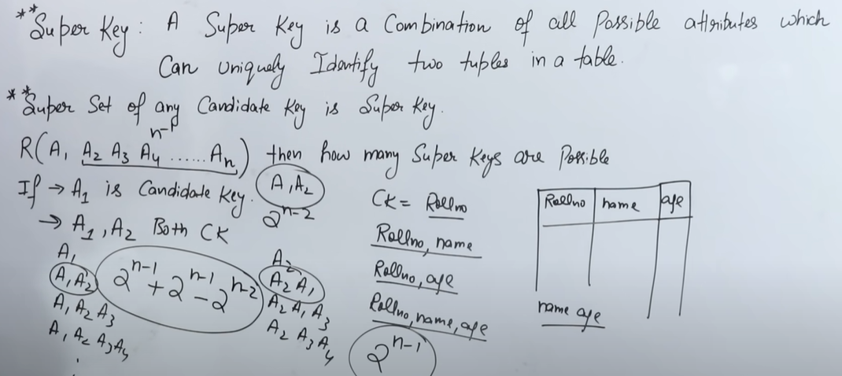

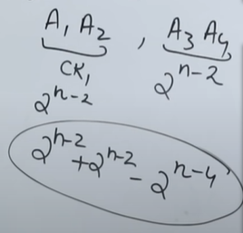

ER MODEL: entity relationship model – type of Diagram

Similar to blueprint before making a Building

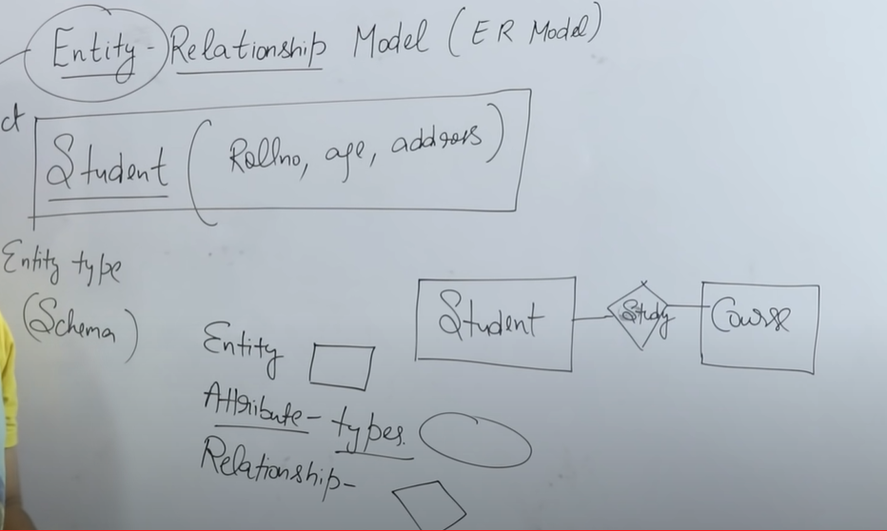

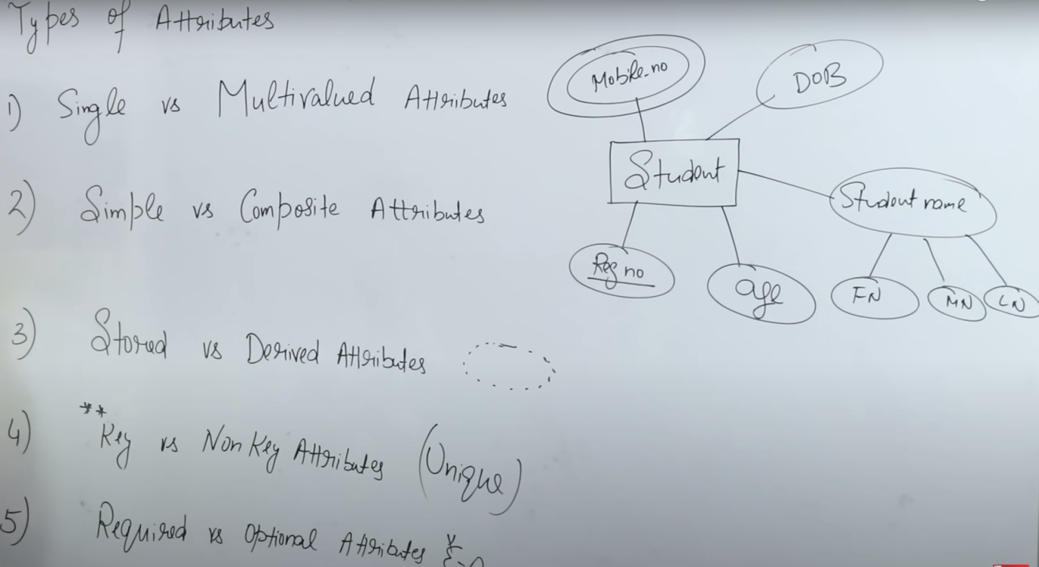

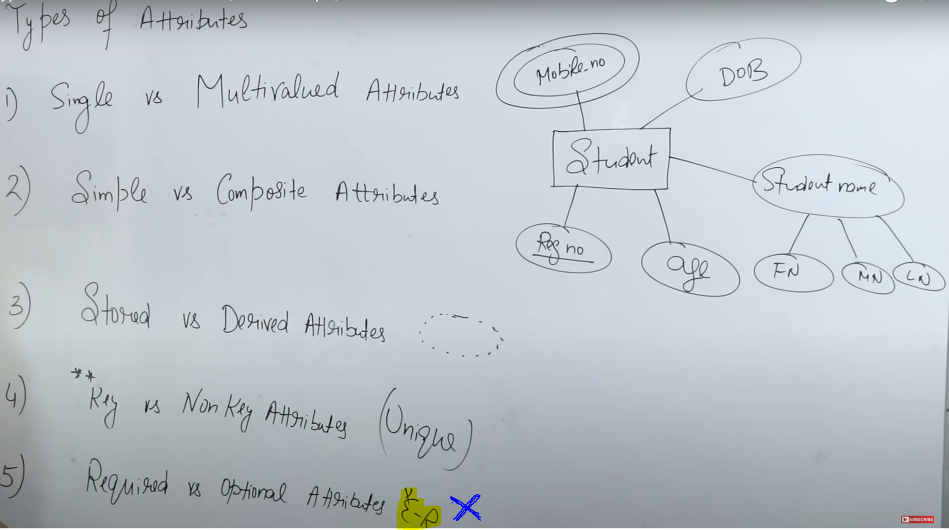

RELATIONSHIPS IN DBMS: One to One, Many to One, Many to Many

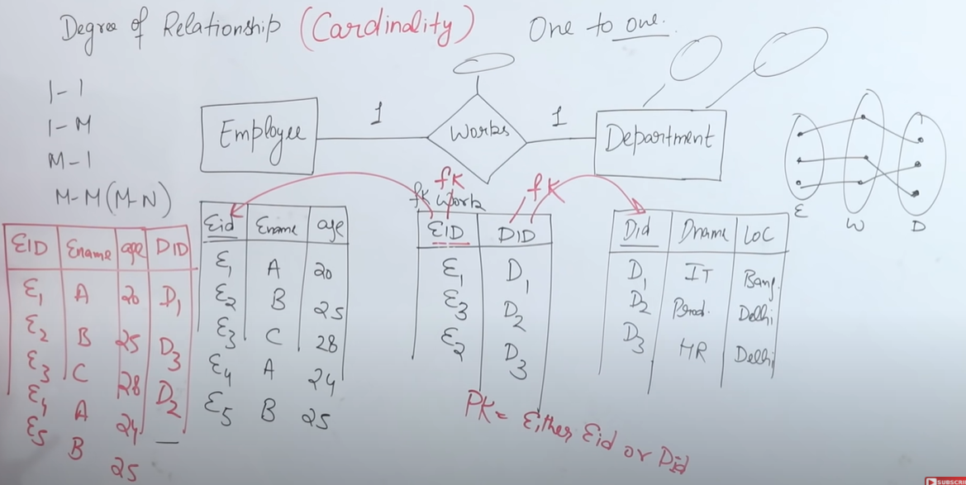

The tables can be merged to get 2 tables at end. In this way One to one helps to implement the ER model to Relational Model.

ER model is used for designing. The implementation of ER model is done using SQL.

NORMALZATION:

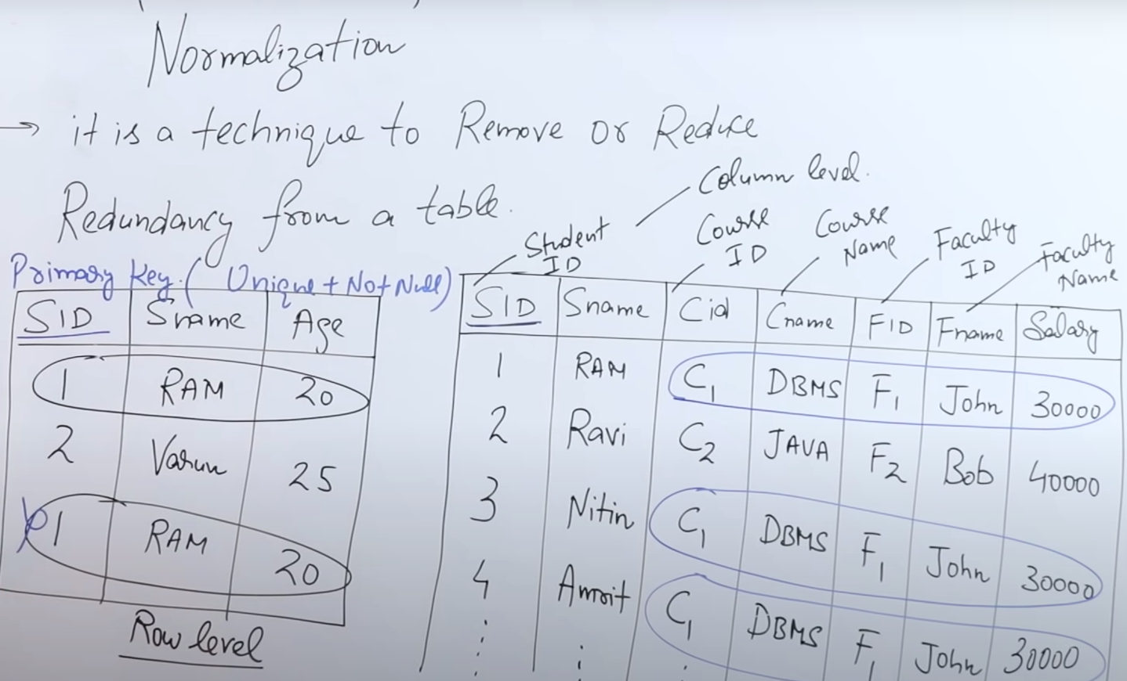

First Normal Form: In below table, the PK can be composite of Roll No and Course

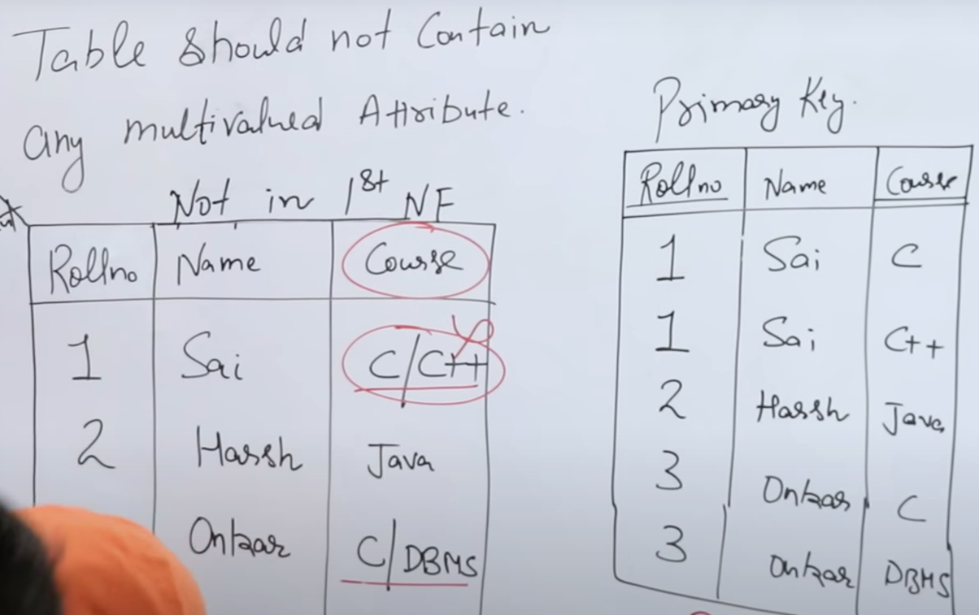

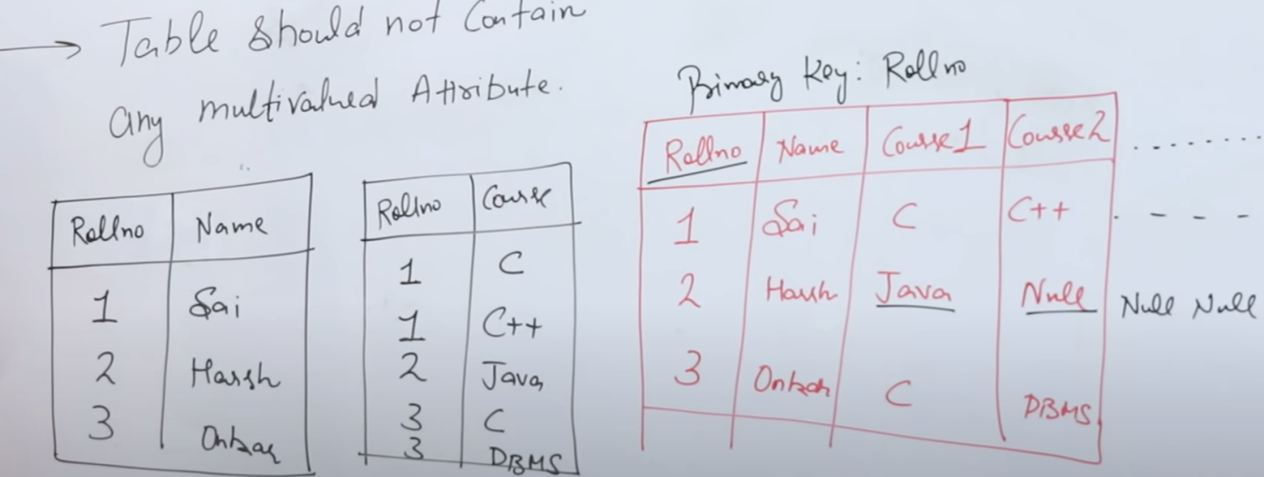

Above are the 3 ways to convert to 1st Normal Form. In the 3rd case, if there is only 1 course, there will be multiple NULLS in other columns. And in the 2nd case, we make one referencing table.

JOINS: CROSS PRODUCT + some CONDITIONS

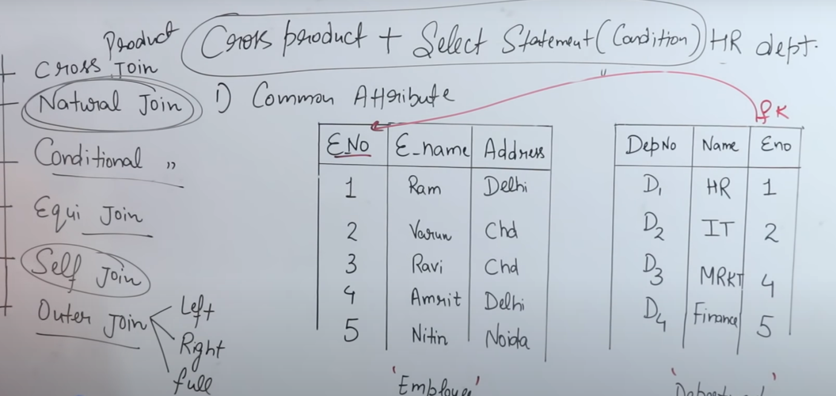

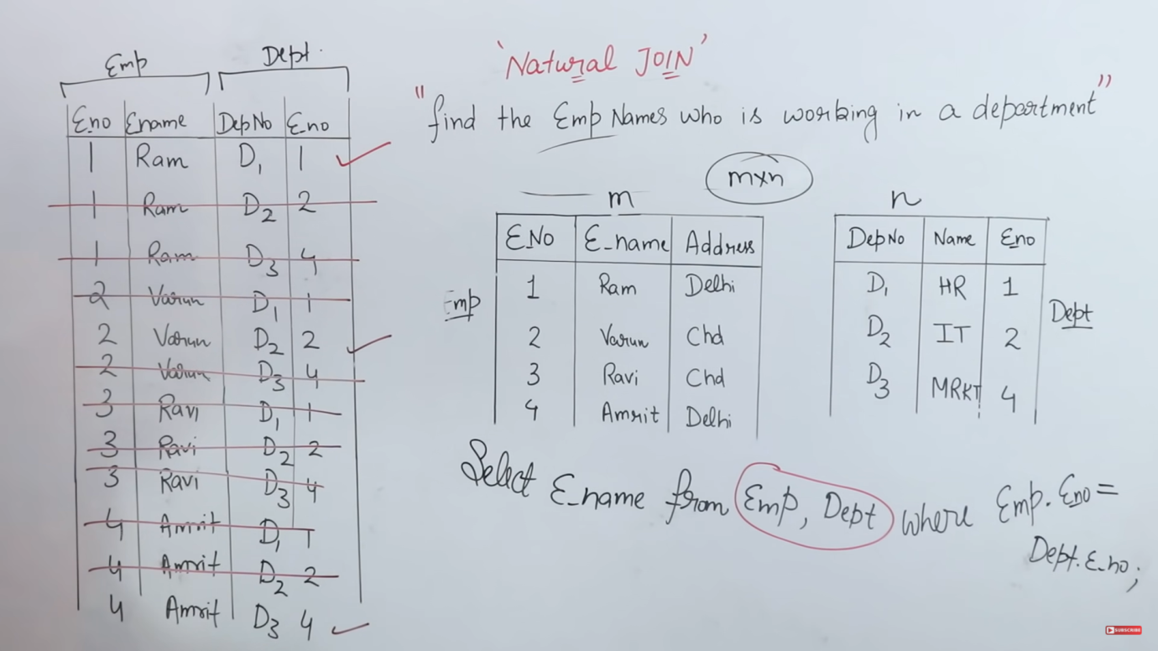

SELECT E_NAME FROM EMP NATURAL JOIN DEPT.

For NATURAL JOIN keyword to use, both should have same name columns.

Self Join:Table is joined with itself

, is nothing but CROSS PRODUCT.

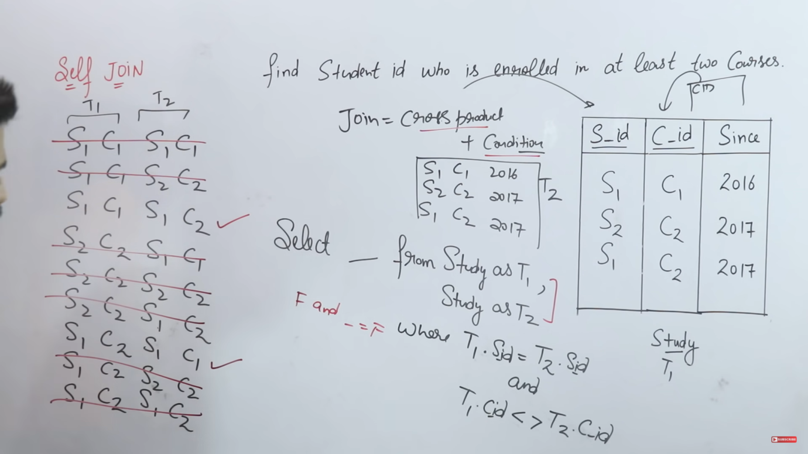

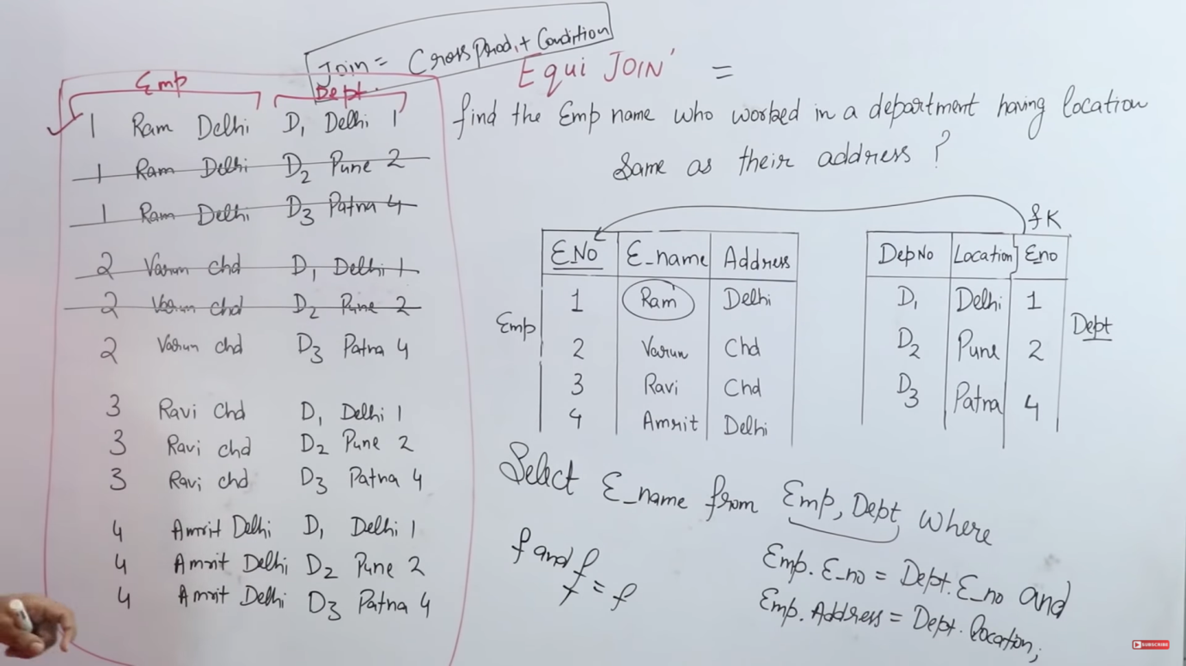

This is same as Natural Join. But in Natural Join we need to compare same attributes from both the tables while in EQUI JOIN, we can compare any two attributes.

LEFT JOIN and LEFT OUTER JOIN are the same.

| **SR.NO.** | **NATURAL JOIN** | **INNER JOIN** |
| --- | --- | --- |
| 1. | Natural Join joins two tables based on same attribute name and datatypes. | Inner Join joins two table on the basis of the column which is explicitly specified in the ON clause. |
| 2. | In Natural Join, The resulting table will contain all the attributes of both the tables but keep only one copy of each common column | In Inner Join, The resulting table will contain all the attribute of both the tables including duplicate columns also |
| 3. | In Natural Join, If there is no condition specifies then it returns the rows based on the common column | In Inner Join, only those records will return which exists in both the tables |
| 4. | SYNTAX: SELECT * FROM table1 NATURAL JOIN table2; | SYNTAX: SELECT * FROM table1 INNER JOIN table2 ON table1.Column_Name = |

Co-related Subqueries:

Query inside a Query